**RTI Manual**

**Setting up for the highlight RTI Image Capture**

**Equipment needed**

* Digital camera and lens
* Remote camera trigger
* Tripod
* One or two reflective spheres plus support (black or red)
* Portable lighting unit
* String
* Matt paper or non-reflectant background (for small objects photographed indoors)
* Spirit level
* PC with the following software installed:
* Java
* RTI Builder
* RTI Viewer
* Adobe Photoshop and Bridge (for any additional edits: rotation, basic image adjustments)

**People needed:** at least two people are needed for measuring lighting distance, handling the portable lighting and triggering the camera.

**Digital Camera and Lens (owned by the department)**   
Camera: Canon EOS 750D  
Lens: Canon EF-S 18-135mm F/3.5 -5.6 IS STM

First attempt was using Laura’s camera: Canon EOS 5D Mark III with EF 100mm F2.8 lens  
Camera was set to manual mode: 1/60th second at F8 at ISO 100. Colour temperature was set manually for 5500K. Camera Raw was the selected output.

**Remote camera trigger (owned by the department)**  
Canon RC-6 remote trigger  
This trigger works wirelessly and can trigger the camera from a distance away from the object. It must be directed towards the front of the camera (as this is where the camera’s built-in receiver is located).

**Tripod**A solid tripod is needed along with the ability to orientate the camera downwards using a moveable centre column. A bubble level can be used to ensure that the camera is parallel to the ground/surface.

**Spheres**One or two spheres (of different sizes – for different sized objects) are needed for every setup. One ball works fine in the RTI software and doesn’t take up valuable image space.  
Balls were purchased from: <https://www.allaboutpartybags.co.uk/party-bag-fillers/balls/black-bouncy-cannon-ball.html> and a set of snooker balls (check with Amy – can’t remember)

**Portable lighting unit**  
Our preferred option was a remote flash unit triggered wirelessly. This was because it was more practical, lightweight, wireless, easy to handle and overall faster to use.  
We experimented with the department’s LED lights but realised that they are heavier, needed to be plugged in all the time and cast extra shadows due to the disposition of the LEDs in rows. And when inserted in the RTI software, it didn’t work.

**String**  
String is used to ensure that the distance from the object to the flash remains constant throughout the shoot (regardless of the angle used). The distance should be relative to the size of the object.

**White background/paper**Matt paper or a non-reflectant surface should be used as a backdrop for all objects. This ensures that the shadows clearly show on the image and do not interfere with the RTI software.

Spirit level  
This ensures that the camera is set parallel to the object.

**PC with Software (Windows PC or bootcamp on Mac – the Mac version of RTI doesn’t download properly)**  
Java – this must be updated before the RTI software is installed.   
RTI Builder and Viewer is downloadable free from http://culturalheritageimaging.org/What_We_Offer/Downloads/)  
PTM fitter software (free at: <http://www.hpl.hp.com/research/ptm/downloads/agreement.html>)

Adobe Photoshop and Bridge (although not essential) are used for rotating images and basic image adjustments (if necessary). If only RAW files are captured, Photoshop and Bridge can automatically produce a set of jpegs to use in the RTI software.

REMEMBER: THE OBJECT; THE SPHERE(s) AND THE CAMERA SHOULD **NEVER MOVE** ONCE YOU START THE PROCESS

**Step-by-step guide (for floor based objects – with the camera looking down on the object)**

1. Turn on the camera and ensure the recording quality is RAW+JPEG 

We actually realised that only JPEG might be good enough

1. Ensure the **sleep mode** is set for **2 minutes or turn it the sleep mode completely off** – if the camera enters sleep mode, you’ll have to touch it, which will change its position and you will have to restart the sequence of shots.
2. Ensure the colour balance is set of Flash (or 5500K if your camera allows)
3. Zoom lens Canon EF-S 18-135mm f/3.5-5.6 IS on the Canon EOS 750D – this means that the lens has a 1.6x zoom factor (compared to a frame camera) i.e. 18mm is really 28mm. You should use the wide angle setting sparingly especially for objects as this can show distortion of the object. Equally too long a focal length (135mm or 216mm on a full frame) may have too short a depth of field. Therefore the optimim focal lengths on this lens for this type of photography is between 50 and 85mm (which is also conveniently marked on the lens).
4. Setup the tripod with the inverted central column – this ensures that the distance between camera and object is correct and also ensures that the camera is parallel with the ground.
5. Place the camera on the inverted column

There is a quick-release plate which you attach to the camera and lock it on to the tripod. Make sure to then **LOCK** the camera into place.

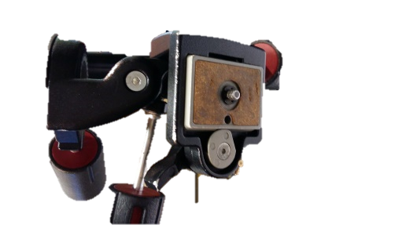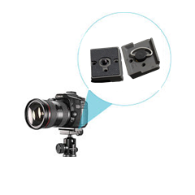

1. Use a spirit level so you are 100% sure that the camera is parallel to the surface.
2. Set timer of the remote flash trigger (if possible, leave 2 seconds between pressing the button and firing the flash so you have time to remove the piece of string and avoid strange shadows). **[Insert icon]** 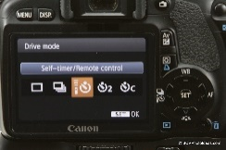

We used ISO 100 – this is the camera’s sensitivity to light (the lower the number, the sharper the image you’ll get). 100 is the lowest setting on our camera.

(Laura used Macro lens but we shouldn’t need this with our camera).

1. Place the white surface on the floor and artefact to be photographed with the reflecting sphere by it.

The size of the sphere depends on the size of the artefact (Direct proportionality)

Place the sphere in an area whereby the shadow cast by it does not interfere with the object (some test shots may be needed).

The top of the sphere should be at the same level of the artefact – this will ensure that it’s in focus. The top third of the ball must be in focus as this is where the specular highlights are and the software needs them to be sharp.

After placing the ball and the artefact together, press the shutter button half way down to focus on the subject, then switch to manual focus (on the lens). This ensures that the subject is in focus but that all further images in the set will be exactly the same (if autofocus is used throughout – there will be slight differences between images and this will affect the final results).

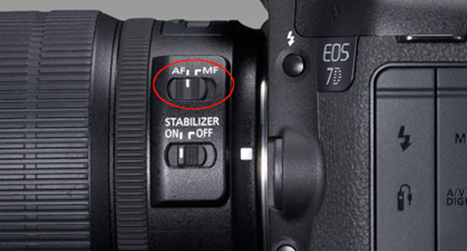

1. In order to know how far you should place the flash use a piece of string: measure half the width of the object’s surface and multiply it 3 times.

We discovered that the size of the string, when using 85 focus on a c.5cm(?) object, was about the distance between the floor (horizon) and the camera. However, if using a 55 focus, on a larger object (c.12cm?), the string must be a few centimetres (c.8?) longer than the height of the camera. Remember to cut the string with **extra length to tie it/hold it to the flash or LED lights**.

1. A test shot should be taken (using the string at the correct distance). Set the camera for F8 and the shutter speed at 1/60th of a second. The flash was set for 1/32power. The flash should be set reasonably high for the test. If the resulting image is too dark – you should increase the power of the flash i.e. 1/16. Or if the image is too light – you should decrease the power of the flash. A second test shot should then be taken to sure that the exposure is fine. It will also show the shadow from the sphere – this is your last chance to make changes before the sequence of shots begin!
2. Take photographs placing the flash at the correct distance by using the string and following the dome/umbrella/clock structure.

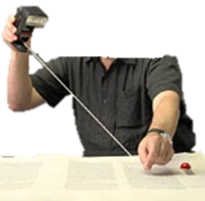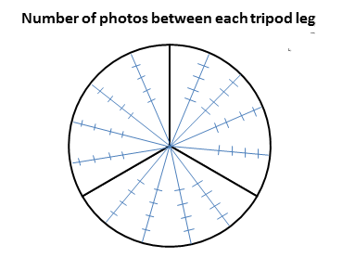

Although the manual states that you should NOT place the flash in lines, we did it. To avoid this, zigzag the flash.

Experts suggest 48 to 76 photographs. (We did 53).

The **higher the number, the better**, so that the changes with the light may be more visible. Try to get as close to the tripod legs as possible, as long as they don’t create a shadow that shows on the object.

The flash must be moved between eash shot. The distance is always set by the string. The angle of the flash is key and should range between 15 degrees and 65 degrees. This is the optimum range of angles – too low and the shadow will interfere with the object - too high and the lighting will be appear flat.

When you finish, transfer the photographs from the camera to your computer.

**Optional -** If you need to make any adjustments through Adobe Photoshop/Bridge – this is the time. Adjustments include rotation, convert to jpeg, lens corrections and sharpening.

1. **Open the RTI Builder app**

**RTI software:**

- Once you’ve downloaded the free software and taken the photos, **connect the camera to the computer**. Make sure the camera doesn’t go into sleep mode until you have all the photos in the computer.

- Create a folder under the **C: directory**, with **NO SPACES**. The RTI Builder software doesn’t process folder/file names with spaces.

- Create a **top-level project folder**, typically naming it with the object name and catalogue number.

- The project folder must contain these subfolders: **projectFolder/; jpeg-exports/.**

- Add your **jpeg images to the jpeg-exports** folder.

- Open the **RTI builder**:

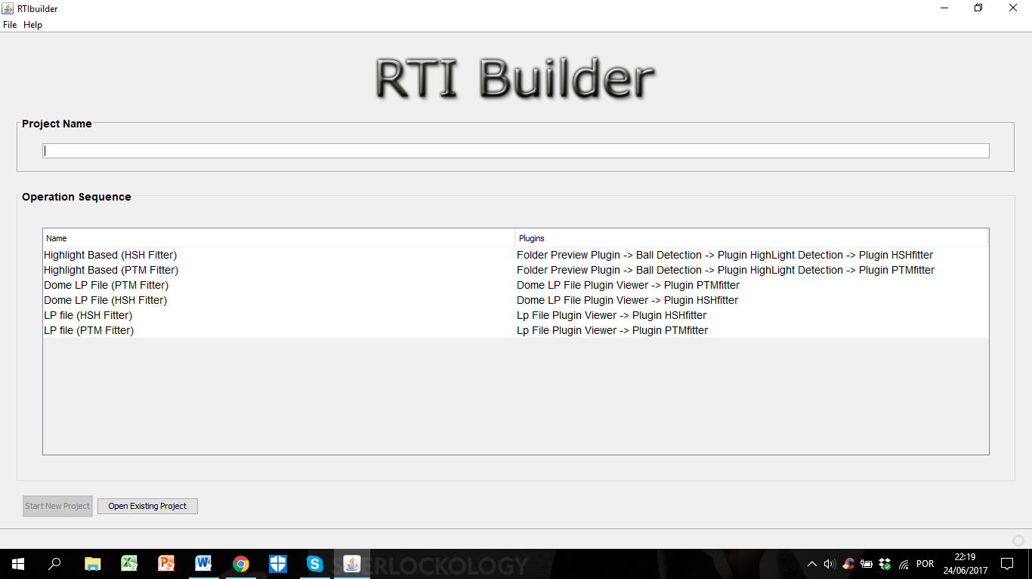

- In the first screen, you can either **create a new project**, or open an existing project to create a different PTM or RTI file from the same image data.

- **Name the project** (object name and catalogue number), **without spaces**.

- Select the **Highlight Based** operation sequences, using the **HSH Fitter**, and press **Start New Project**:

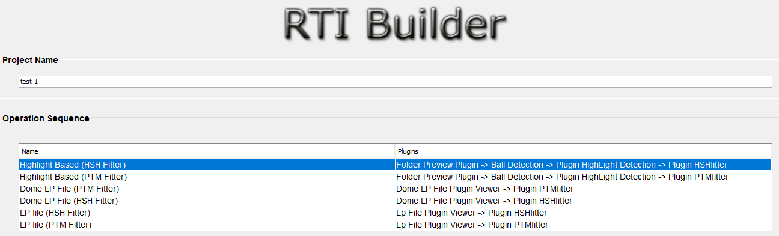 

- On the next screen, click **Open Folder** at the right of the window, and browse to the top-level project folder. This is the folder which contains the jpeg-exports image files. Select the folder and the “**Loading Images**” window should appear. The import might take some time.

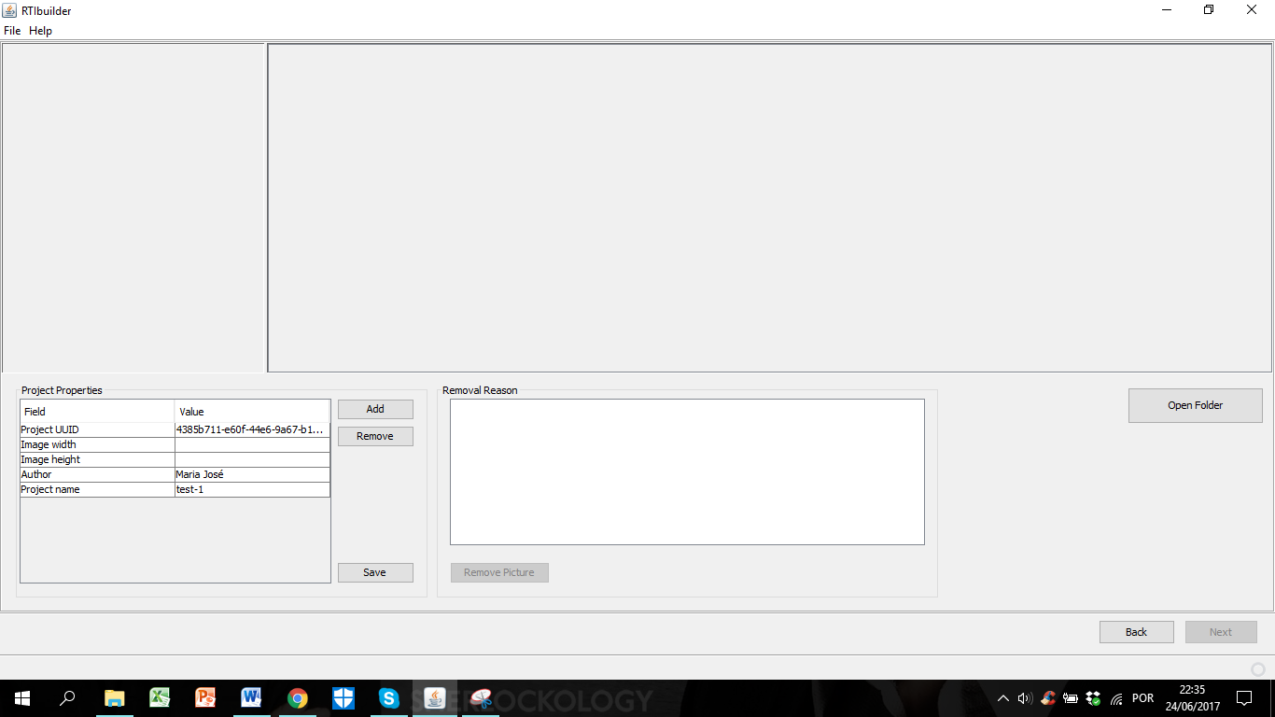 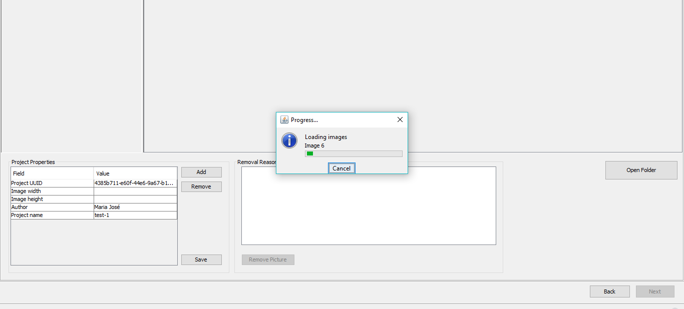

- After loading the images, they should all appear like the following image:

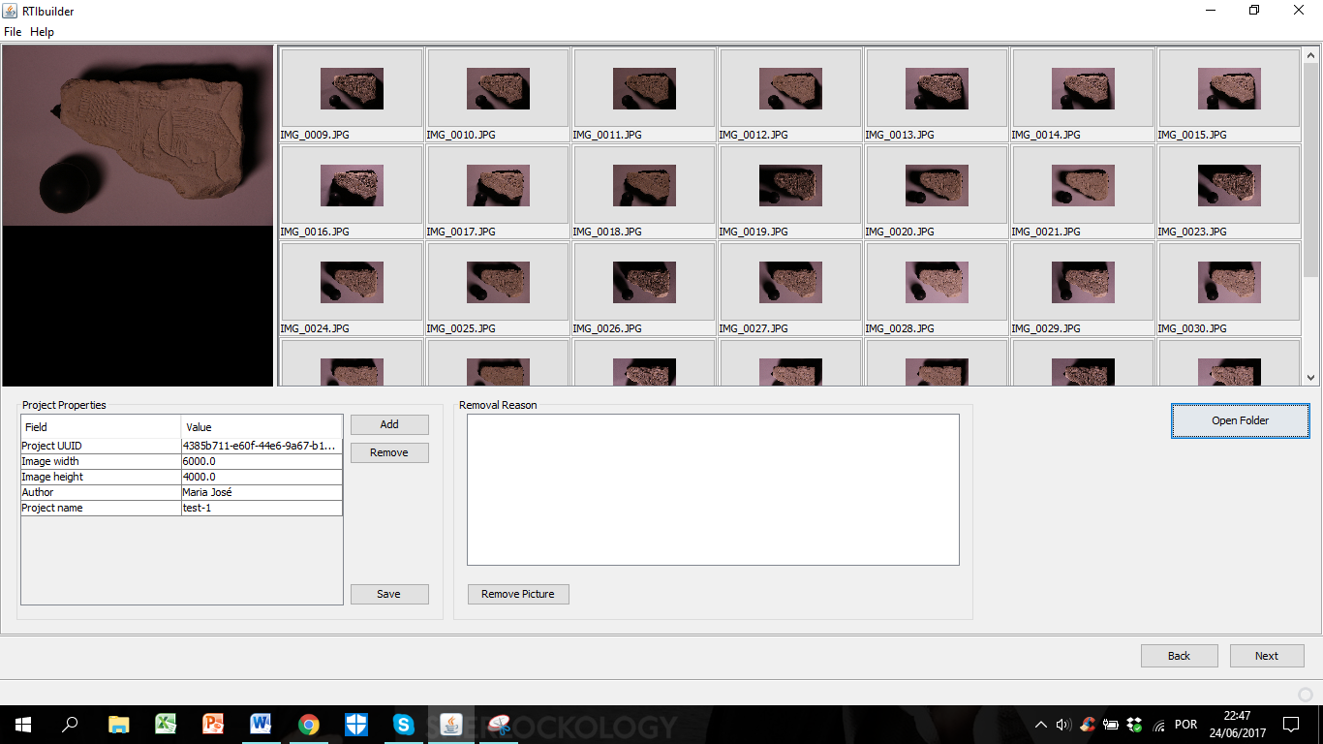

- Use the **removal section** to remove **any images that should not be used to calculate the RTI**. These images are removed only from the set of images to be processed; the **image files are not deleted**. Select the image or images you want to remove; click Remove Picture to apply the change to the image set. After (or if no image is to be removed), click **Next.**

- Select the **type of ball (Black or Red)** you used. Mark the area using the mouse to select a rectangular region that includes an entire sphere. This region becomes **green**. Ensure that the highlighted area is **larger than the sphere**, and that the **sphere edge is completely included** within the box. After, click “**Add Area**”. The area should turn **red**.

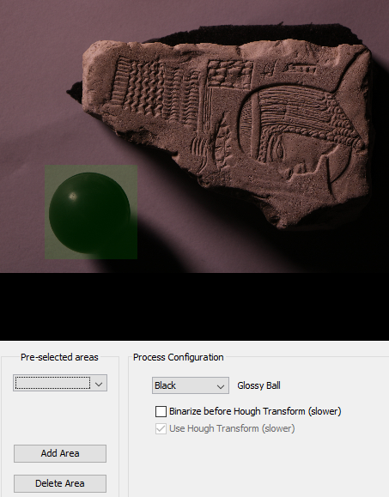 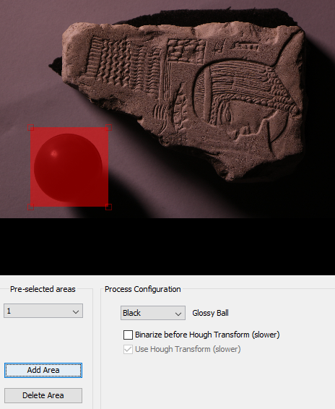

- Click **Detect Spheres**. The processing takes some time. When it is completed, the upper left panel shows the detected sphere.

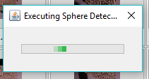

- Next, adjust the **sphere centre**, if necessary. If you do change it, after moving the red line and centre cross, click **Set New Centre**. After, click **Next**.

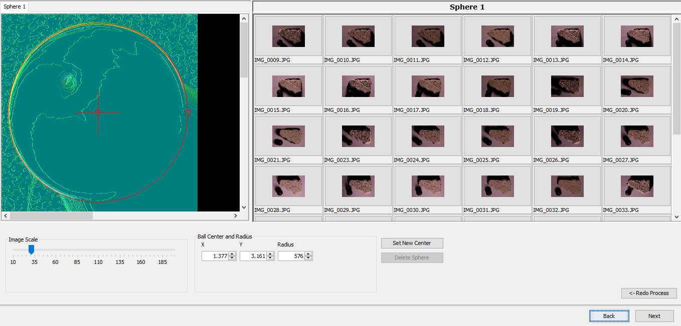

- Make sure the sphere’s centre is in the right place and click **Highlight detection**. This is a lengthy operation. When it has completed, the red circles around the sphere images change to small, red + marks at the centre of each highlight.

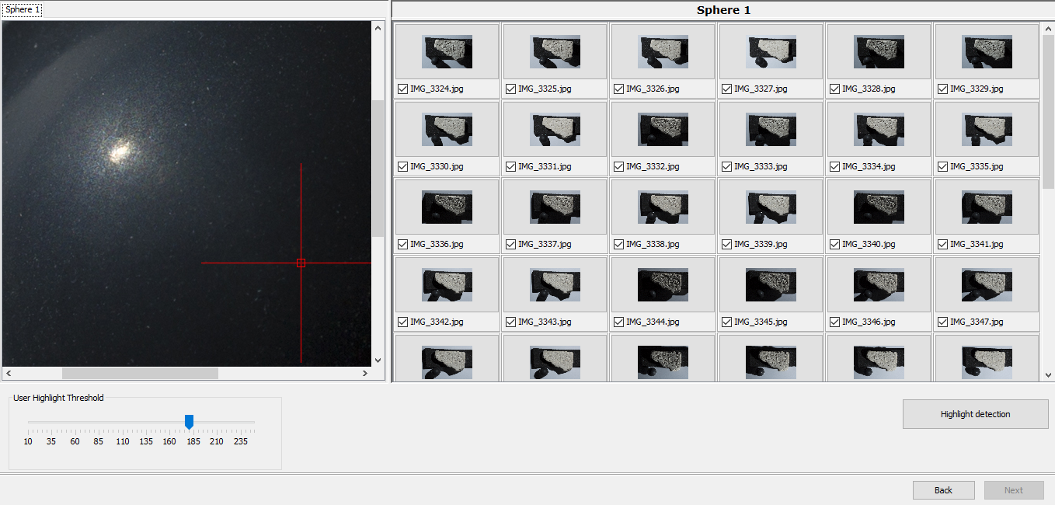

- The software generates the following files:

a **blended image** showing all the highlights in the set, in the assembly_files/ subfolder. You can scroll to the bottom of the thumbnail images in the RTI Builder to see this image.

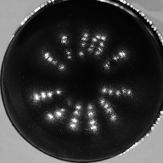

a **light position (LP) file** with the extension .lp, which is used to generate the RTI. This is written into the assembly_files/ subfolder that contains the JPEG image files.

an **XML log file** named <projectName>.xml, written to the top-level project folder.

- Next, you can **crop the spheres out of the photos**, if you want or simply create the RTI file with them in the image:

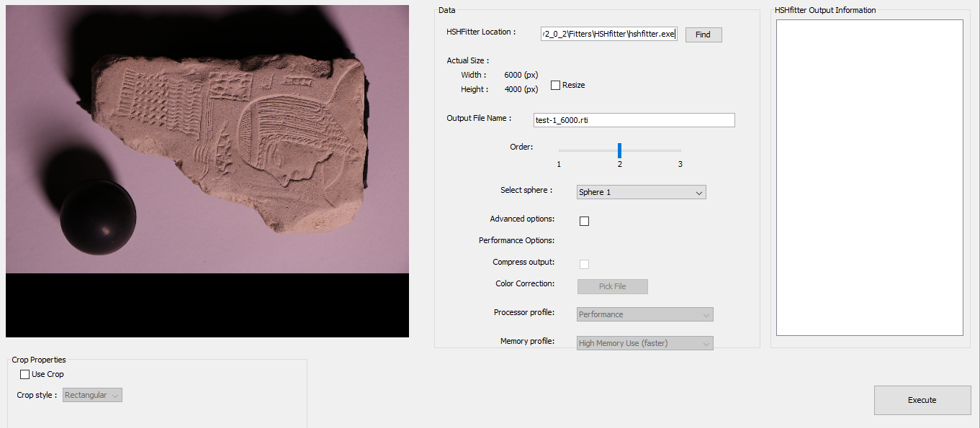

- Click **Use Crop**. You can use **rectangular or free-hand crop** areas to crop down the image to the portion you want to include in your finished RTI. If you select Rectangular, use the mouse to draw out the crop region. Adjust the region using the resize handles in the corners. If you select Free, click on the starting point of the shape. Each mouse click draws a dotted-line segment in the image. The final click should be on the starting point. Adjust the crop area as closely as possible around the target image. If you need to start over, click Clear Crop.

- Click **Execute**. This will create a **PTM file** which appears on the **finished_files/** subfolder of the project folder. You can generate several PTMs with different image cropping, size, and colour type (LRGB/RGB) options. After creating a PTM, simply change the parameters and generate another. If you do this, however, be careful to use unique names to distinguish the results. **RTI Builder does not check for an existing file with the same name.** If a file with the same name exists, it is overwritten without warning.

- If you are using the **PTM algorithm**, the first time you run RTI Builder, you must **enter the path to the ptmfitter file**; that is, the location where it is installed on the local computer. The software remembers the location, and you do not need to set it again.

- When it’s complete, it should say something similar to this:

Sample Image -> W: 5760 H: 3840 Channels: 3; Parameters read successfully; HSH matrix : Rows= 4 Columns=106; Number of Threads : 8; **Time spent in compute_loop : 175**

- Go to your original top-level folder and open the **Finished Files** folder. There should be a **.rti** file. Click on it to open the **RTI viewer**:

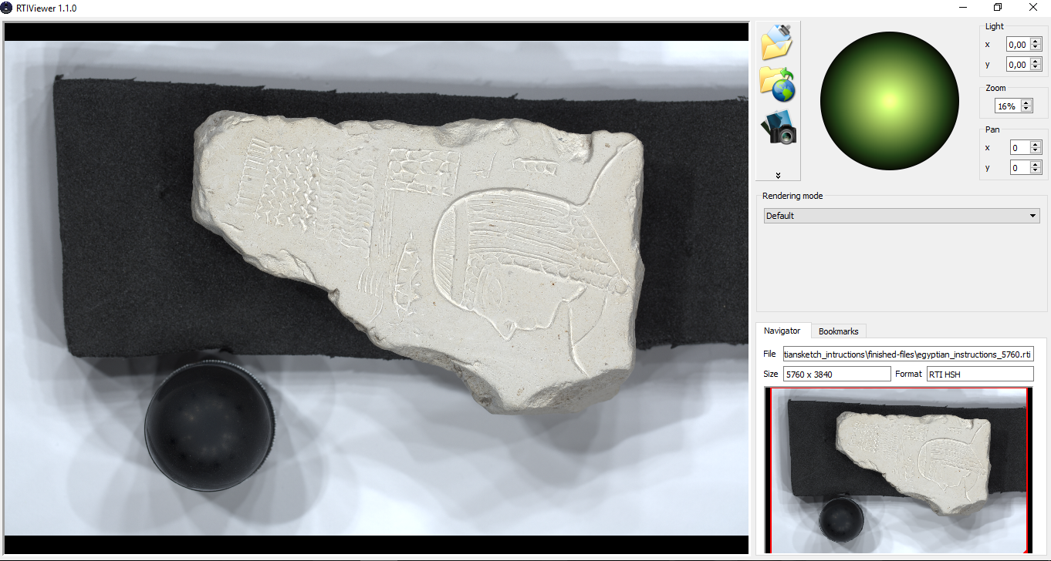

- Choose the version you want to see from the three options available: **default** (above), **specular enhancement**, and **normal visualization**. You can take **snapshots** with the **camera button** and save them in the same folder.